Contents

Android Assembly Pictures 2

Merchandise 3

Play Test Feedback & game rules 4

Website 6

Trello board 7

Individual Work 8

Individual Work Humam 8

Individual Work Tamara 9

Individual Work Rob 10

Individual Work Rick 11

Individual Work Olivier 12

Individual Work Glyn 13

Teamwork reflection 14

# Android Assembly Pictures

# Merchandise

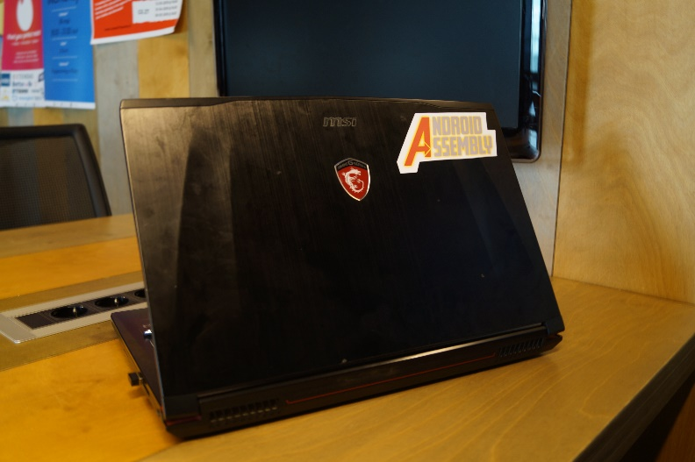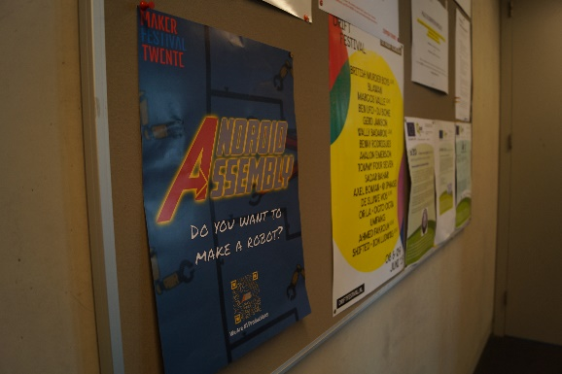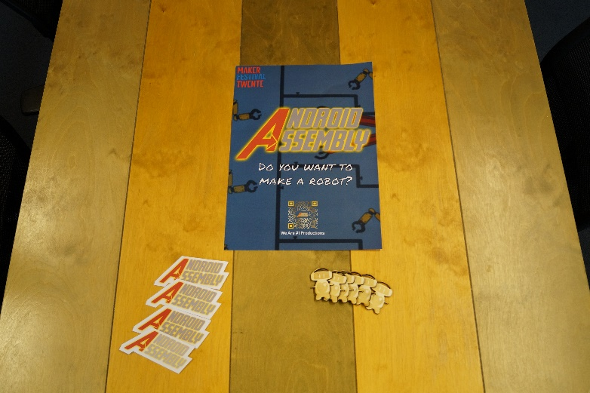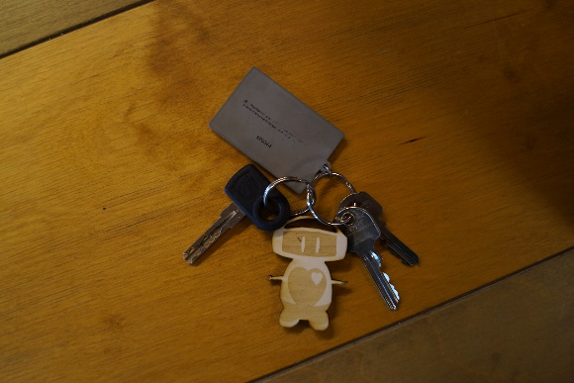

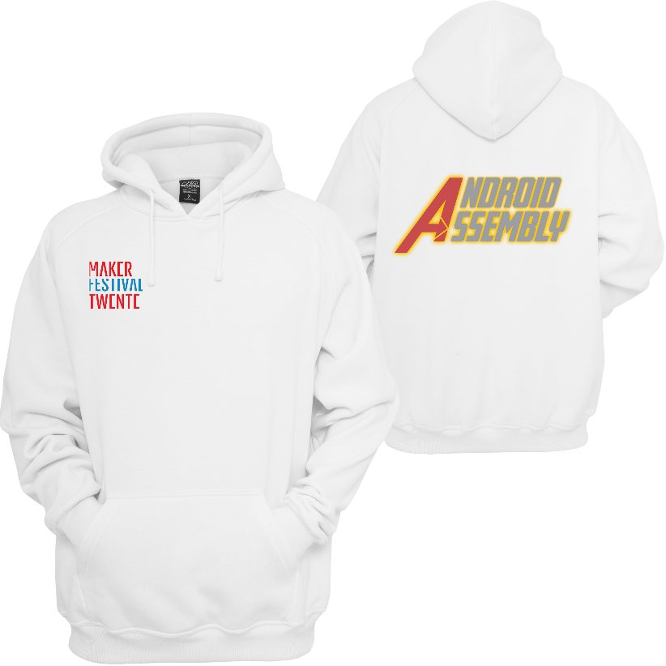

Play Test Feedback & game rules

**Processed Feedback**

**Positive points:**

The concept fits really well together between GXP and the mechanical bit.  
Concept fits really well with the target audience.  
The robot is a really fun idea.  
The art style is really nice and fits well with the children  
The theme overall makes sense  
The simplicity really fits the younger audience  
Aligns with metropolis well  
Magnet vs Fan is a really nice dichotomy  
Really cool robot design

**Discussion points:**

|  |  |
| --- | --- |
| Failure State | |
| Feedback for | Feedback against |
| Without failure state it can get boring really quickly(Especially older kids) | No failure state is nice for younger kids who have no experience with the mouse/anything |
| Without failure state the kids don’t learn | The game is too short for the kids to notice there’s no failure state anyway |

Arguments in group discussion: Objective isn’t to learn game but learn real-world knowledge. We target the younger audience overall. More of a toy than a game. It’s impossible to appeal to the entire range of 4-12 with one game, thus our focus is mostly on the young. Younger kids can still play.

Conclusion: After the arguments we voted on the option of a failure state(automatic reset) or no failure state at all. We voted and got 5-1, we talked to the last person who wanted it to be failable and presented our arguments and voting again after the result was 6-0 in favour.

|  |  |
| --- | --- |
| Art style too dim | |
| Feedback for | Feedback against |
| The art style has too much gray in it | Art style is really nice and simple and fits the children |
| The colours are very dim |  |

Arguments in group discussion: Assets are super colourful, so actually putting the assets on the backgrounds will make them pop and make this a non-argument. We changed the robot colour from gray to a brighter white to see how that looked.

Conclusion: We really liked the brighter white robot version so we changed to that, but kept the rest of the art unchanged.

|  |  |
| --- | --- |
| Longer chain reaction | |
| Feedback for | Feedback against |
| The chain reaction might be over so quickly they don’t notice it | People really liked the way it currently flows |

Arguments in group discussion: We disagree it’s too quick, with the max being 30 seconds we feel like our current ~20 seconds is already fine.  
Conclusion: No change.

Android Assembly Game Rules

Website

Links:

<https://tinyurl.com/androidassembly> (For easy typing on mobile)

Android Assembly website is hosted via google drive and then drive to web.

# Trello board

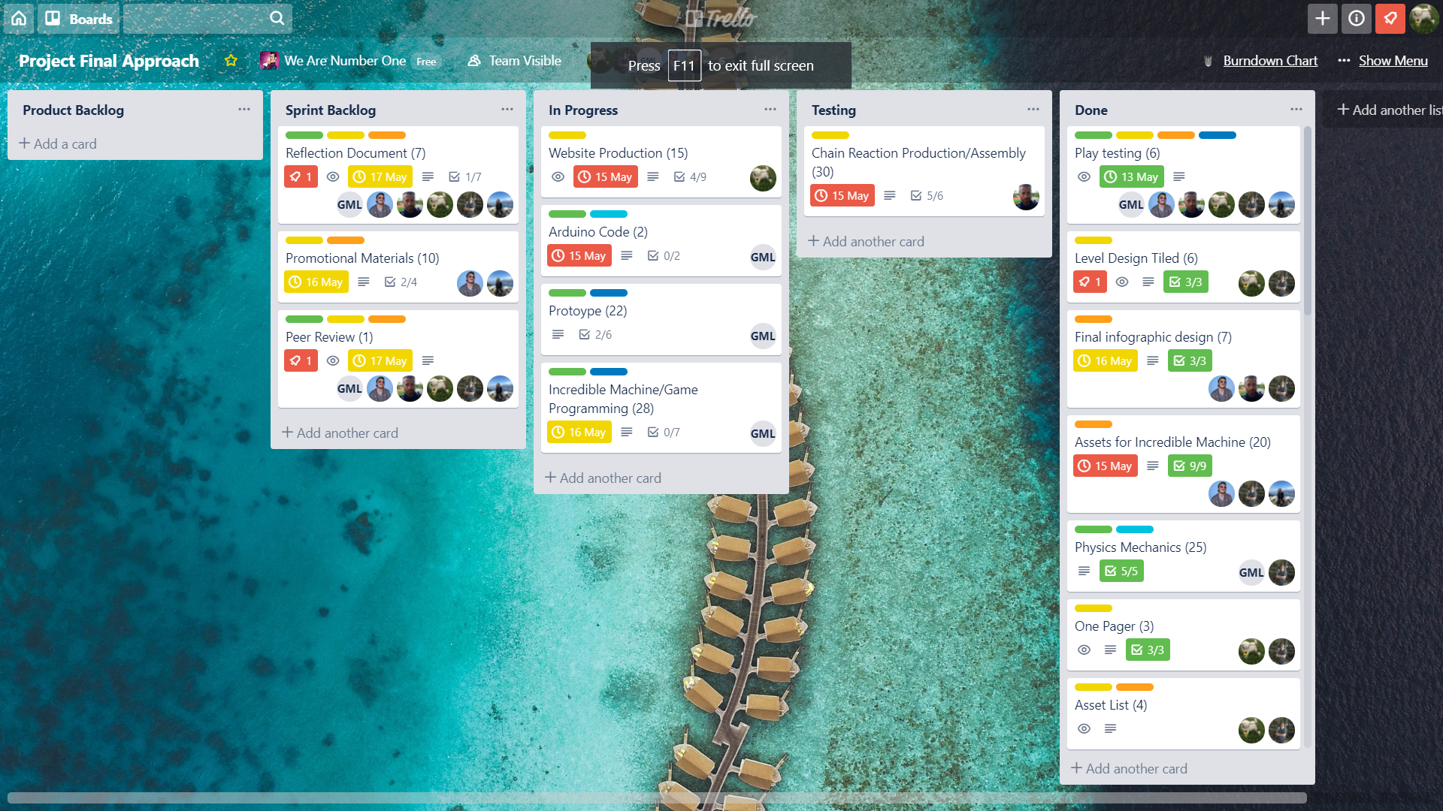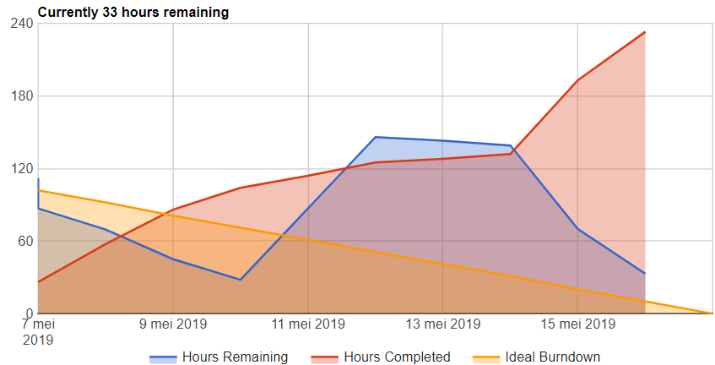

Trello explanation:

Here are our Trello board and burndown chart, as you can see the burndown chart is pretty steady until about the 15th of may where we finished a lot of story points but we’re pretty happy with how the flow of work went over the two weeks. Most of the finished story points on the 15th of may had been worked on before, but the 15th of may had a lot of finishing up work.

On the Trello there’s roles; Artist, Designer, Programmer and for the programming tasks it’s split up into engine development and gameplay programming. Each task has a role and programming ones have a role and a description. Each task has a user story and a check list which needs to be worked through and when those are completed those are the grounds of completion. Each task also has one or more people on it, depending on who’s supposed to work on it. When it goes to testing, the tester also puts their name on it so that when something is wrong there is full accountability.

The Trello structure goes as follows: Product backlog, Sprint backlog, In Progress, Testing, done.  
Everything for the project is in the product backlog. Things that are to be done in the current sprint go to the sprint backlog. When someone is currently working on it, it goes to in progress. Then when the checklist is complete it goes to testing. Once it is approved by the tester it goes to done. At the end of the day all tasks that are in progress should be moved back to the sprint backlog and story points spent should be logged on the burndown chart.

# Individual Work

## Individual Work Humam: Sound Designer/General Artist

I spent most of my time creating an auditory experience so it enhances the feel of the project by having music and audio effects that are in tandem with the visuals. There are sound effects that will play simultaneously with the chain reaction. I have also made the initial sketches of the character and most of the objects used in the digital part, so mostly all the 2D elements. I have also worked with Tamara and Rob to agree on the final sketch of the robot, so it was a collaboration of all artists. Other than that, I also created the logo of our installation, designed and created the info-graphic with all the content, alongside the poster itself. I made the infographic with circular layouts because circles appeal more to children and are more friendly. I have added a short description of each step of “making the robot” that is not too obvious nor too vague. The intention was that the info-graphic creates an image in the head of the person reading that prompts him to press the button and find out how the experience will play out.

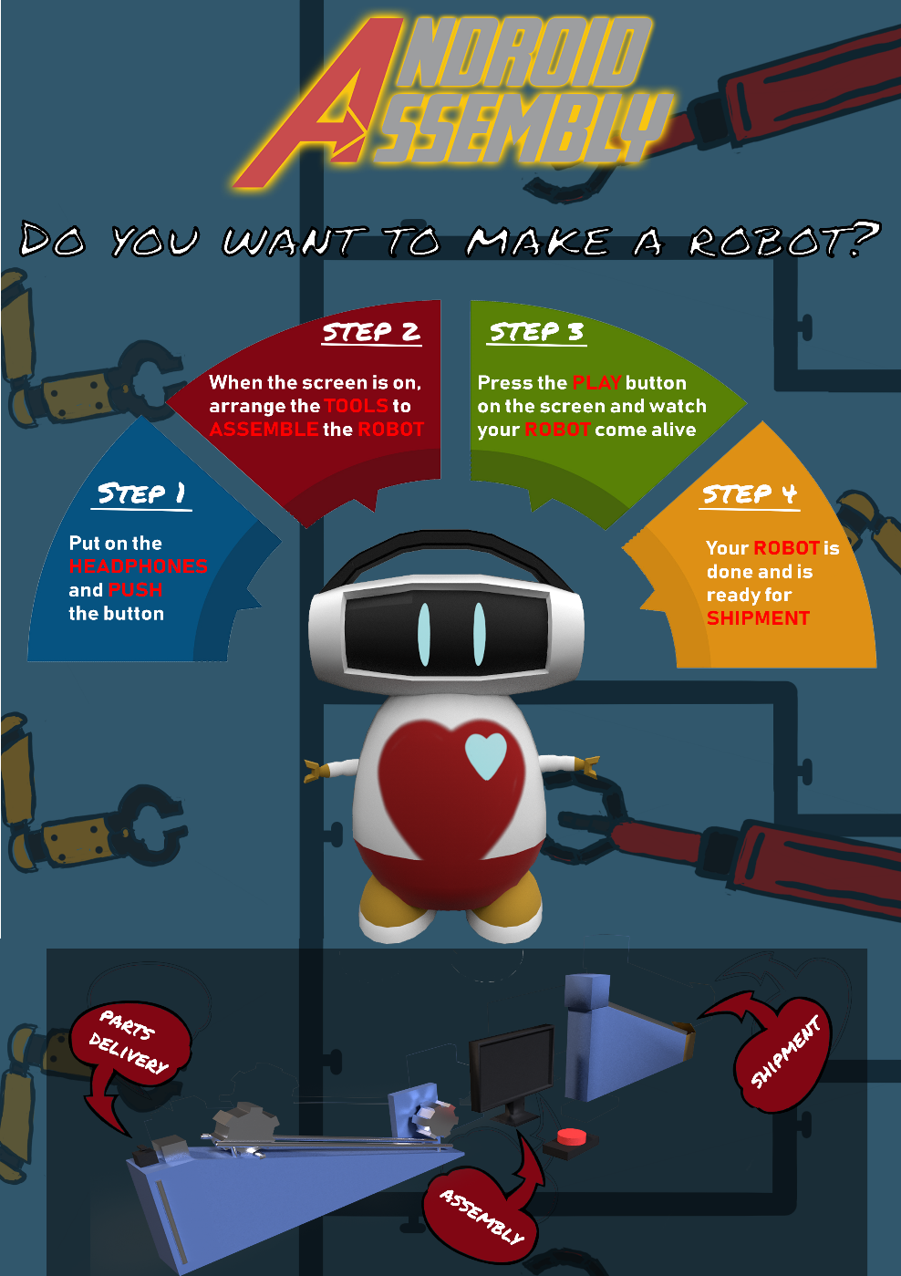

h

## Individual Work Tamara

## Individual Work Rob – Scrum Master/ 3D Artist

My primary focus over the 2 weeks were 3d modelling (The main character and a render of the chain reaction) and Scrum Master/Project Management. I enjoy scrum a lot and I volunteered at the beginning to be scrum master, as you can see from the Trello section of this document my system is fairly standard but it works very effectively, there was no real crunch period in this project which in my opinion means the planning went very well. Some of the things that I think I could do better as a scrum master for the next project is put more pressure on people to log there used story points on the burndown chart to make that more accurate.



My other role as an artist I also feel went quite well, at the start I focused on stuff like figuring out the general style of the game with Humam and Tamara, and then I made the mood board, which was a challenge as it had 4 different iterations before it was good enough. Then my primary focus was 3D modelling the main character which we intended to 3D print, I successfully modeled and textured the character however, I left it too late to prepare the model for print, which is a lesson I learned and will know in the future. I also was the primary tester for a lot of the user stories on this project because I had a very good overview of the tasks.

**Full list of things I did:**

Character Model

Incredible Machine Model

General Assistance

Project Management

Mood Board

Testing

## Individual Work Rick

Created the HTML/CSS for the website and all the written content on there.  
Created the initial game design.  
Created the levels for the game in tiled.  
Made the PowerPoints.  
Made the majority of the design documents such as the justification document, the game design document & the one pager.  
Led the play tests as well as processed the feedback and led the group discussions about them.  
Wiring and testing for the Arduino/electrical components.  
Illustrator files for laser-cutting.

## Individual Work Olivier

Post pictures/write a list of what you have done

## Individual Work Glyn

Post pictures/write a list of what you have done

# Teamwork reflection

**What were the challenges/problems you faced as a team and how did you face them?**

During the feedback processing we had a conflict where the engineer disagreed with the decision to not implement a failure state. We had a vote and it was 5-1, so we discussed it with him and let him explain his reasoning to us after which we explained our reasoning to him to see if we could sway him. Holding a second vote afterwards led to a 6-0 result.

We also had a problem with deciding who from our team deserves the green card, we all felt everyone deserved it, so we resolved this by deciding who ever scored highest on the peer review would get it.

**What were the roles and were the roles respected?**

At the beginning we defined our roles very clearly before we even had a concept. Glyn would be our GXP programmer, Rick would be our web developer and Game Designer, Olivier would be our chain reaction designer and producer, Tamara would be our 2D animator, Rob would be our 3D artist and Scrum Master and Humam would be our 2D artist and Sound Designer.

We respected everyone’s roles by stating clearly at the start that everyone (within reason) could make a decision about their task, we also came with a positive attitude every day and gave constructive feedback instead of just saying something like “make it better”, we gave some feedback as to how to make it better.

**In what ways did you manage to help each other outside of your roles?**

The biggest way we helped each other outside of each other’s roles was voting on all big decisions made about the direction the project. This gave the team a democratic feel and made production go very smoothly. We also did a daily stand up where each person said what they did the previous day, what they plan to do today and raise any issues they have.

On the last day all artwork had been finished, so the artist were all hands on deck to help Olivier finish the production of the chain reaction.